Explaining Some main keywords in python

**___**

By Marim Mohamed Goda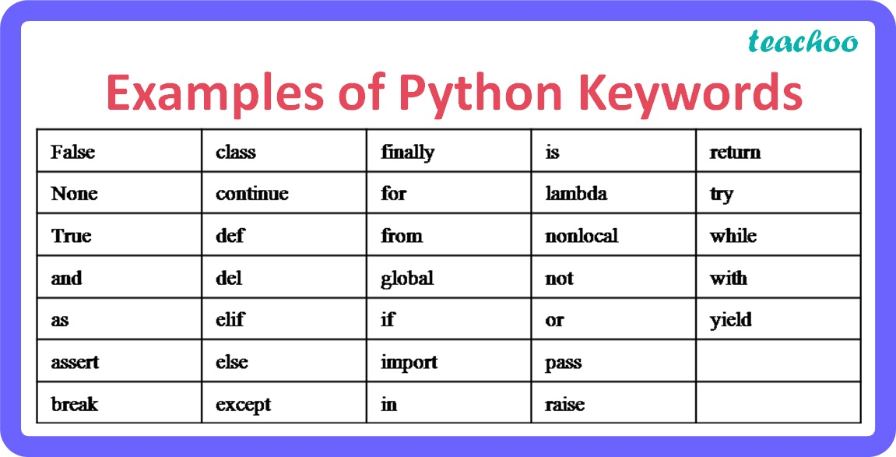

# 

# 

# 

# 

# 

# 

# Introduction:

This document is going to explain a small brief for each keyword in this table, to help us identify the main usage for each one.

# Python Keywords:

* False : it is a boolean value that represents a false value or zero integer.
* True : it is a boolean value that represents a true value or one integer.
* None : it express the empty value or nulls
* And : it applies the same operation of and logic gates that return one or true only if all cases are true.
* As : used in aliasing when importing a library in modified term to facilitate calling it.
* Assert : it is used during the test of a condition.
* Break : it is used when it need to get out from a specific block of code and go to other block.
* Class : keyword used to define a class.
* Continue : it is used to when it needs to skip this iteration and go to the next one.
* Def : it is used when it needs to define a function.
* Del : it is used when it needs to delete a specific attribute or an item.
* Elif : it is a combination between else if its condition came after if condition and apply if condition is false.
* Else : last condition that applies when if and elif conditions are false.
* Finally: its role is applied after trying to cleanup the code.
* For : used in looping .
* From : specify what model you are going to import from it.
* Global : used in declaring a global variable.
* If : the first statement condition or the starting point of applying the conditions.
* Import : used to call the module that you need.
* In : check if the membership is in a sequence or not.
* Is : see the identity of the object.
* Lambda : it is used when in need to make an anonymous function.
* Nonlocal : declares a variable in outer function.
* Not : it applies the same operation of not logic gates .
* Or : it applies the same operation of or logic gates .
* Pass : it's like a placeholder.
* Raise : it is used to raise an exception.
* Return : it is used in return for the value of a function.
* Try : define a block of code and test it.
* While : used in looping with a condition.
* With : Simplifies resource management .
* Yield : Pauses and resumes generator functions.